Phase 7 – SQL server Practical
Step 1 – Add SQL server to the docker-compose.yml
Step 2 - Install packages in the Product.API
cd "D:\MICROSERVICES\MICROSERVICES\Project\Product API\ProductAPI_Phase1"
dotnet add package Microsoft.EntityFrameworkCore.SqlServer
dotnet add package Microsoft.EntityFrameworkCore.Tools
dotnet add package Microsoft.EntityFrameworkCore.Design

Step 3 – Install packages in the Order.API

cd "D:\MICROSERVICES\MICROSERVICES\Project\Order API\OrderAPI_Phase2" dotnet add package
Microsoft.EntityFrameworkCore.SqlServer dotnet add package Microsoft.EntityFrameworkCore.Tools dotnet add package Microsoft.EntityFrameworkCore.Design

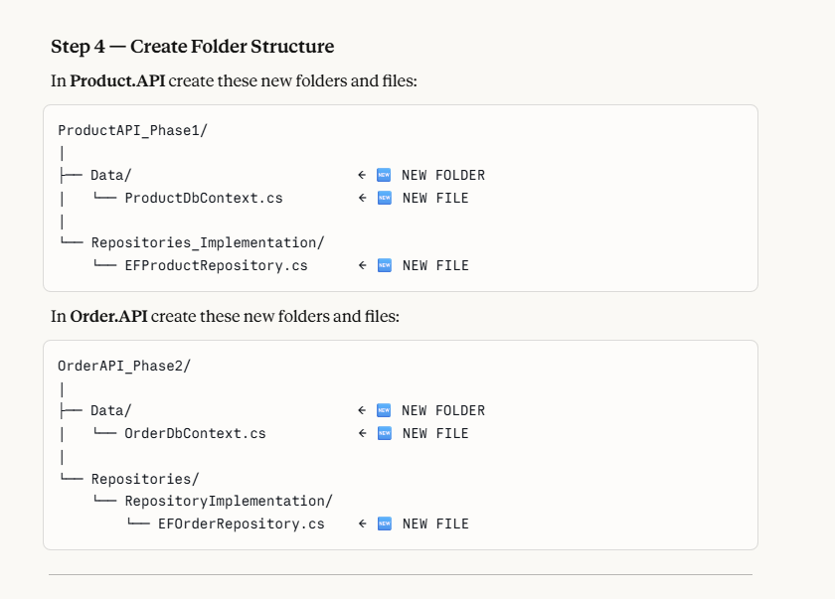

STEP 1 : Now what we are doing in the ProductDbContext ? (refer the productdbcontext code)

- Adding seed data – that is initial/default data, that gets inserted once when the database is first created
- Your app: First run → Database is empty
- Seed data → stocks database with 3 sample products
- ONCE After that → real products added via POST /api/products
- In production you would remove seed data and add real products through the admin panel.

What is OnModelCreating?

OnModelCreating is a method that runs once when your app starts — it lets you configure how your C# models map to database tables. It is like setting rules and own conventions to the database tables while creating it.

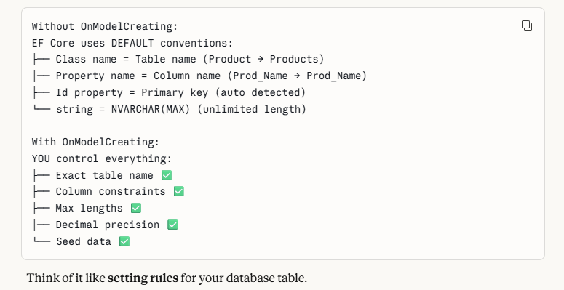
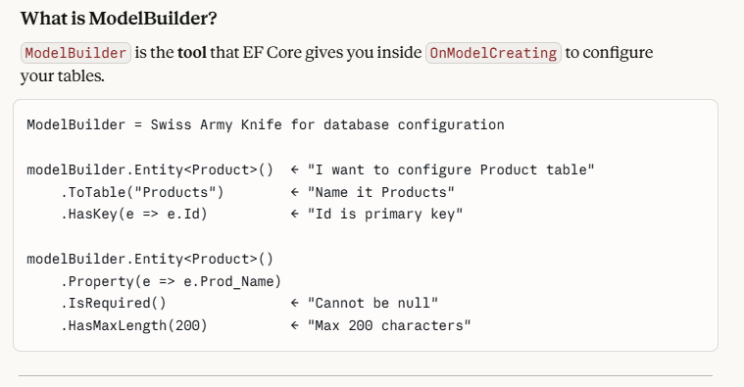
OnModelCreating = "Setup rules for my database tables"
ModelBuilder = "The tool I use to write those rules"
Seed Data = "Initial data to populate empty database" Not hardcoding — just starter data ✅

STEP 2 : WRITE CODE IN THE EF_PRODUCT REPOSITORY

- Now we are going to add methods for writing the code with the database pointing,
- Previously in the InmemoeryRepository we used hardcoded values, now we are moving towards the database sql server.
- And we are going to add Generic repositories pattern
- Create IGenericRepository class file under the Respositories folder
- Create EFGenericRepository.cs file under the Repositories_Implementation folder
- Refer the summary notes in each file to get the details

STEP 3 – WRITE CODE IN EFGENERICREPOSITORY.CS.

- Here we implement the methods that have been defined in the IGenericRepository interface
- These hold the common methods which can be implemented for any entities
- 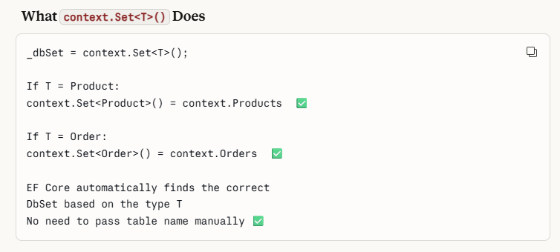
- After creating common methods in generic repository, we can modify the methods in the IProductRepository.cs and write product specific code in the EFProductrespository.cs
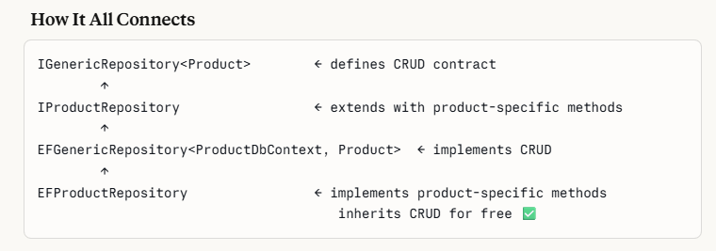

- Next update the Program.cs for the interfaces we have created. We need to Addscope to the interfaces created, then only the service runs
- Refer the modifications made in the program.cs, where we have given the automigrate feature as well.
- I have added a screenshot of what changed after moving to the Sql server option in program.cs

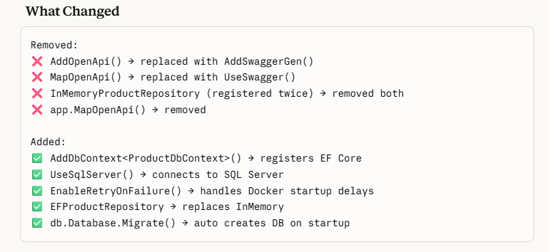

- Now add the connection string in the appsetings.json
- Now after adding the connection string , we are going to run the sql server in the docker compose
- So run the below command in powershell to start the sql in docker
cd "D:\MICROSERVICES\MICROSERVICES\Project"
docker-compose up sqlserver -d

verify the sql is running in docker
docker ps

You should see:```
sqlserver Up X seconds (healthy) 0.0.0.0:1433->1433/tcp

This starts only the SQL Server container. Wait 30 seconds for it to fully initialize.

STEP 4 : AFTER RUNNING THE SQL SERVER – RUN THE MIGRATION IN THE CODE

- Once SQL Server is running, open terminal in Product.API folder:
- Run the command below for the migration
- Imp - Before running the migrations , check the product services where the sql server logic have been replaced with the static one, or else while building the app or running migrations you will get error
- Check the errors by giving “dotnet build”
- Once errors are not there you can run the migration be seeing to the below file
- After migrations ,you get the migrations folder created in the product api
- Check whether the sql server container is started and running in the docker
- Once the sql server keeps running in the docker , you can update the migration, pls refer the 3rd screenshot where the migration is getting updated to the database
